The story of linguistic relativism
Vilém Zouhar
2019/2020

Abstract:
The Sapir–Whorf hypothesis states that the various properties of a language determine the native speaker’s experience of the world. Further research and scientific progress in linguistics disproved the strong version of the hypothesis (that the language determines the experience). This means that even if members of a cultural group do not have an expression for a given concept, it poses no significant obstacle in their communication, nor understanding of the external world.
The idea that language and thoughts are related appeared long before the Sapir-Whorf hypothesis. It was partly explored in philosophical debates in the 18th and 19th century by romantic philosophers and misused as an argument for ethno-nationalist pursues.
After the enticing idea of the strong version of the Sapir-Whorf hypothesis ended, linguists by the end of the 20th century sought to revive linguistic relativism in the form of a relaxed version of the claim (that the language influences the experience). This proved to be less problematic and thus we can safely establish that there is a connection between the speaker’s knowledge of language and classification of concepts and their behaviour. Empirical research was done in the areas of space, time, shapes and colour perception. The study of Sapir-Whorf related phenomena is an undisputable part of cognitive linguistics.
Lastly, since this hypothesis can be easily explained in layman’s terms, it is not short of appearances in popular culture.

Sources:
- http://lera.ucsd.edu/papers/linguistic-relativity.pdf (space, time, shapes, ontologies)
- http://www.academypublication.com/issues/past/tpls/vol02/03/30.pdfhttps://www.bsu.by/Cache/pdf/203213.pdf (evolution of Sapir and Whorf)
- https://www.coloradocollege.edu/dotAsset/3bb4c139-8a46-4238-a5b9-67bca5209ae6.pdf (mechanisms of linguistic relativity)
- https://benjamins.com/catalog/avt.13.09elf/fulltext/avt.13.09elf.pdf (pre-Whorf)
- https://pdfs.semanticscholar.org/82d7/1b38b1faddfee77a81e4b6ba64c0514f6752.pdf (both pre- and post-Sapir-Whorf)

Inspiration:
- http://www.blutner.de/color/Sapir-Whorf.pdf
- https://www.bsu.by/Cache/pdf/203213.pdf
- https://en.wikipedia.org/wiki/Linguistic_relativity
- https://en.wikipedia.org/wiki/Linguistic_relativity_and_the_color_naming_debate

Introduction
Languages can have vastly disparate attributes ranging from the presence of grammatical gender and tenses to different distribution of word orders and approaches to word formation. This all results in very dissimilar world ontologies. Because of this, it may appear that speakers of different languages perceive the world in a largely different way. This idea has been explored by scholars already from the 19th century, peaking in the 20th century and is still a subject of contemporary research.
This proposition is known as linguistic relativism, but also as the Sapir-Whorf hypothesis and can be coarsely simplified into two versions.
- The strong version, known as linguistic determinism, claims that the language completely determines the perception of the world.
- The weak version, known as linguistic influence, claims that language determines the perception, but only to some limited extent.
Language relativism is an interdisciplinary issue, as it is relevant not only to linguistics but also to psychology, sociology and philosophy. The story of linguistic relativism can be described as an evolution of an idea, which was developed mostly iteratively from generation to generation, each represented by a single most prominent scientist.

Development before Sapir
The origins of linguistic relativism are related to Emanuel Swedenborg, a Swedish theologian of the 18th century. Even though the idea that language and cognition may be connected can be traced as far as Plato and later St. Augustine, Emanuel Swedenborg was one of the first to state this more explicitly in his 1771 book The True Christian religion, where he mentions the common genius of people speaking the same language.

“It is well known that the inhabitants of every kingdom that is divided into several states are not alike in genius; and that these differ from one another in particular points just as those who live in the various countries of the globe have their general points of difference; but still that there is a common genius prevailing among those who are subject to one king, … However, as a common genius prevails everywhere among people speaking the same language, …” (Swedenborg, 1771)

Wilhelm von Humboldt, a Prussian philosopher of the 18th century, used similar ideas in his work as a linguist and claimed that the Worldview (der Weltansicht) is the reflection of the mindset of different cultures and language communities. He used these ideas in the proposition that inflectional languages, such as German, English and the other Indo-European languages were the most perfect languages. In this manner, he explained that this is the reason that the Europeans were able to dominate the speakers of “less perfect” languages. (Baofu, 2012)

Humboldt’s ideas of language and worldviews became an established concept to which future generations of linguists reached back.

Boas’s work
Close to a century later, a German-born American scientist Franz Boas, who is sometimes referred to as the father of American anthropology, took part in an expedition which aimed to study the culture and language of the Inuit. He was a vocal opponent to scientific racism, which was popular in the 18th century. (Gossett, 1969) He also claimed that human behaviour was not predetermined, but rather acquired through exposition to different cultures (Moore, 2009).

He supported the concept of cultural relativism. According to him, cultures can not be objectively compared to one another in terms of quality or efficiency (Moore, 2009). In the argumentation for this idea, he holds that “Cultural and linguistic categorization is imposed on experience in ways that differ from language to language.. “ (Taylor, 2008).

Boas assumed universal characteristics of the human mind, criticizing the earlier idea that “primitive” people are not capable of abstract thought and that all human beings are assumed to conceptualize abstract categories on the basis of experience (Elffers, 1996). His work in general suggests that comparison of both cultures and languages is irrelevant, as the differences can be explained by the fact that people experience cultures and languages in different manners.

Sapir’s work
Edward Sapir, an American anthropologist, linguist and a student of Boas, continued in his teacher’s endeavour by studying native American languages. Sapir argues that connections between race, culture and language are virtually non-existent. This is stated more than clearly in his 1921 book Language:
“... all attempts to connect particular types of morphology with certain correlated stages of cultural development are vain. Rightly understood, such correlations are rubbish. The merest coup d'oeil verifies our theoretical argument on this point. Both simple and complex types of language of an indefinite number of varieties may be found spoken at any desired level of cultural advance. When it comes to linguistic form, Plato walks with the Macedonian swineherd, Confucius with the head-hunting savage of Assam.” (Elffers, 1996)

To the previous statement, Sapir adds an exception, arguing that the differences in vocabulary ontologies, morphologies and other grammatical parameters are connected to the specific culture’s requirements (Elffers, 1996). This is stressed further by the statement: “Language and thought-grooves are inextricably interrelated, are, in a sense, the same.” He, however, distances himself from the 18th-century ideas about linguistic relativism by pointing out that the previous statement applies only to the content of messages and not the way the message is transferred (Sapir, 1921).

Even though Edward Sapir’s name is part of the name of the Sapir-Whorf hypothesis, he only paved the conceptual path and had little to do with stating the actual hypothesis itself. Furthermore, it is conceivable that he would disagree with the strong version of the hypothesis.

Whorf’s hypothesis
Benjamin Lee Whorf, an American linguist and fire prevention engineer, is one of the most prominent figures regarding linguistic relativism. Being a student of Sapir, he further expanded on his teacher’s ideas. Similarly to his predecessors, he started his career in linguistics by focusing on the study of native American languages.
Whorf spent most of his career as a linguist studying the relationship between culture and language. Only in his final two years did he focus on what could be called linguistic relativity. This is apparent from his 1939 article The Relation of Habitual Thought And Behavior to Language.

The article is the main source of citations related to linguistic relativism and is focused on how language patterns influence cultural norms and vice versa. It is clearly manifested in the questions posed in the last section: “How does such a network of language, culture, and behavior come about historically? Which was first: the language patterns or the cultural norms?” Another question from the first section yet further shows how closely this article is related to linguistic relativism: “Are our own concepts of "time," "space," and "matter" given in substantially the same form by experience to all men, or are they in part conditioned by the structure of particular languages?” The article is based not only on studies of the Hopi language but also on SAE (Standard Average European), introduced by Whorf to describe common features among modern European languages. Whorf summarizes the article by claiming that while the experience of time and matter is dependent on the nature of the language, space perception is not.

Similarly to Sapir, Whorf did not state the Sapir-Whorf hypothesis Whorf himself cast a shadow of doubt over any scientific results showing any strong determinism between language and world perception (Beek 2006). The term Sapir-Whorf hypothesis was popularized posthumously by Harry Hoijer and George L. Trager. Whorf’s work in the area of linguistic relativism was criticised for relying completely on anecdotal evidence (Beek, 2006).

Revival and derivative claims
The era after Whorf was focused on empirical research around linguistic relativism. The most investigated area was colour perception, but Whorf’s ideas were refined as well by reformulating the Sapir-Whorf hypothesis in more digestible steps: (Beek, 2006)
- Fundamental differences between languages exist.
- The language spoken by a person has an active influence of that person's worldview.
The difference between the weak and the strong version would then be only the intensity of the two previous statements. The supportist of the hypothesis are called relativists, while the opponents are referred to as universalists. In this context universalist claim that since all speakers share the same biological tools, then all thought and language patterns are within some universal constraints. Since both thought and language patterns are mere products of biological constraints, then there can be no influence between the two.

The research in the area of colour perception was meant to either prove or disprove the second part of the restated Sapir-Whorf hypothesis. Among the first to empirically study this problem were Brown and Lenneberg with their article A study in language and cognition. The way they studied the connection between language and thought in terms of colour perception was to measure reaction times of speakers with different colour codification in colour recognition tasks. (Beek, 2006)
They established that colours for which a language has a name are more memorizable. Further studies (Winawer et. al., 2007) showed that participants performed faster in matching tasks when the colours of the objects were in two different categories (Wolff and Holmes, 2011). This conclusion itself, however, does not prove even the weak version of the Sapir-Whorf hypothesis. This is because different cognitive disruptions of speakers of different languages does not imply, different underlying thought processes.

Experiments were done by the universalists too. One of the most famous experiments on infants was done by (Bornstein et. al., 1976). They observed that all people have some intrinsic categorization of colours based on the colour parameters, such as hue and saturation.

Notable is the 1969 project The World Color Survey (Berlin et. al., 1969b). In this project, native speakers were asked to name all colours (presented at random) and also to pick the major colour out of a presented palette.

Conclusion from this and similar research was summarised by Berlin and Kay in their 1969 book Basic Color Terms: Their Universality and Evolution. They found strong empirical evidence that the categorization of colours in different languages follows a strong guideline. Such guideline restrictions are for example the total number of basic colours or their criteria (e.g. that basic colours have to be noticeable, distinct and nonscarce in the world). The criteria are, however, not generic and define a strict structure of the colour system in a given language. Colour systems in languages are separated into stages with a rule to each stage, such as:

“At Stage V the focus of blue emerges, normally from the GREEN area but perhaps occasionally also from BLACK. In either case, GREEN now becomes green. At this stage, BLACK and WHITE are fully reduced to black and white; i, e., to neutral values. The RED area is probably also reduced with respect to purples and violets.” (Berlin et. al., 1969a)

The description of stages is accompanied by figures, which documents that there is strong evidence for some innate colour system in colour systems in natural languages.

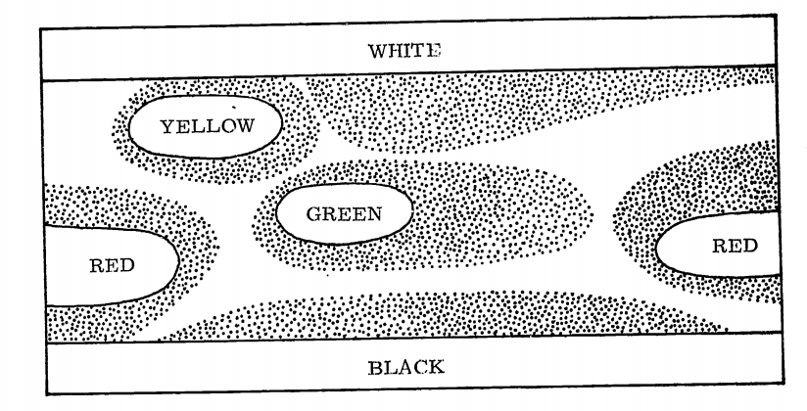
Figure 7 from (Berlin et. al., 1969a): Typical Stage IV Basic Color Lexicon
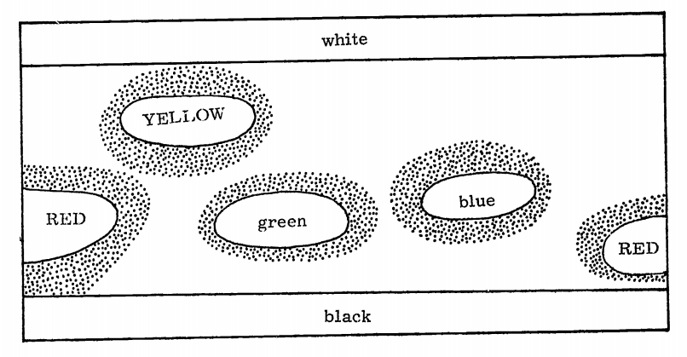
Figure 8 from (Berlin et. al., 1969a): Typical Stage V Basic Color Lexicon

Drawing definite conclusions for either universalist or relativist views soon became controversial. The area of colour perception is still studied today. The main focus is on the acquisition of colour systems and their evolution.

Conclusion
Helmut Gipper, a German linguist and philosopher, asked: “To what extent does language influence us?”, which implies that it’s not about whether the Sapir-Whorf hypothesis is true or not, but to what extent (Hussein, 2012). The lack of conclusive evidence of the linguistic research done in the past century showed that the strong version of the hypothesis is probably false. Research on linguistic relativity is still done today, but the question of the validity of the main hypothesis is much less controversial than it was 50 years ago.
Despite that, the idea that language shapes thought is tantalizing, especially in popular culture. This couldn’t be more apparent than from the 1998 short story Story of Your Life and it’s 2016 movie adaptation Arrival, where a super-strong version of the hypothesis that learning a new language will dramatically change the speakers thought processes, is considered as the main premise. In a similar way, this was explored by George Orwell and Ayn Rand in their respective writings, where language was used to enforce or disallow certain thoughts.

Bibliography
Emanuel Swedenborg (1771), True Christian Religion, translation John C. Ager (1906)

Baofu, P. (2012). The Future of Post-human Semantics: A Preface to a New Theory of Internality and Externality. Cambridge Scholars Publishing

Gossett, Thomas (1969). Race: The History of an Idea in America. New York, Oxford: Oxford University Press.

Moore, Jerry D. (2009). "Franz Boas: Culture in Context". Visions of Culture: an Introduction to Anthropological Theories and Theorists. Walnut Creek, California: Altamira.

Taylor, Christina (2008). Studying Native America: Problems and Prospects. American Ethnologist. 26. 1004 - 1005. 10.1525/ae.1999.26.4.1004.

Sapir, E. (1921) Language; an Introduction to the Study of Speech, Reprint Harcourt, Brace & World, Inc., New York.

The Relation of Habitual Thought And Behavior to Language. Written in 1939 and originally published in "Language, Culture and Personality: Essays in Memory of Edward Sapir" edited by Leslie Spier, 1941, reprinted in Carroll (1956:134–59).

Winawer J, Witthoft N, Frank MC, Wu L, Wade A, Boroditsky L. Russian blues reveal effects of language on color discrimination. Proc Natl Acad Sci 2007, 104:7780–7785.

Bornstein, M.; Kessen, W.; Weiskopf, S. (1976). "The categories of hue in infancy". Science. 191 (4223): 201–202.

Berlin, Brent & Kay, Paul (1969). Basic Color Terms: Their Universality and Evolution. Berkeley: University of California Press.

Kay, Paul; Maffi, Luisa (1999). "Color Appearance and the Emergence and Evolution of Basic Color Lexicons". American Anthropologist. 101 (4): 743–760.

Berlin, Brent and Paul Kay. Basic Color Terms: Their Universality and Evolution. Berkeley and Los Angeles. University of California Press, 1969.

Elffers, E. (1996). The history of thought about language and thought. Linguistics in the Netherlands, 73, 84.

Beek, W. Linguistic Relativism, 2006

Boroditsky, L. (2006). Linguistic relativity. Encyclopedia of cognitive science.

Wolff, P., & Holmes, K. J. (2011). Linguistic relativity. Wiley Interdisciplinary Reviews: Cognitive Science, 2(3), 253-265.

Hussein, B. A. S. (2012). The sapir-whorf hypothesis today. Theory and Practice in Language Studies, 2(3), 642-646.

